Configuration Guide

Project PJT02515: Post Cutover to Interval Billing – August 2015 Release 4C

Document Information 3
Revision History 3
1 Business Scenarios 4
1.1 Table - Bill Install Configuration 4
1.2.1 Organizational Units 4
1.2 Interval Energy Profile 5
1.2.1 Organizational Units – Profile Type 5
1.2.2 Organizational Units – Profile Allocation Role 7
1.3 AMI -Time-of-Use Billing Configuration 8
1.3.1 Organizational Units – Formula Group 8
1.3.2 Organizational Units – Time-of-Use Formula 9
1.3.3 Organizational Units – Time-of-Use Interface 10
1.4 Billing – Billing Master Data Configuration 12
1.4.1 Organizational Units – Rate Type 12
1.4.2 Organizational Units – Operand 13
1.4.3 Organizational Units – Rate 16
1.4.4 Organizational Units – Schema 19
1.4.5 Organizational Units – Rate Category 21
1.4.6 Organizational Units – Rate Determination 21
1.5 Enhanced Message Management 22
1.5.1 Organizational Units – EMMA Case Category 22
2 Contributors 27

Document Information
Document Purpose | Post Cutover to Interval Meter Reading and Billing Configuration
Document Owner | Rajesh Pandey
Business Owner | Zach Pakkala
File Name(s) | PJT02515.SAP.Post.Cutover.Interval.Billing.Configuration.docx
Stored at | SharePoint

Revision History
Version | Date | Author | Comments
0.1 | 02/02/2015 | Rajesh Pandey | First Draft
1.0 | 06/10/20015 | Ed Abranovich | Approved Baselne Work Product

1 Business Scenarios

1.1 Table - Bill Install Configuration

1.2.1 Organizational Units

Type: Table Configuration

Logical Component: Bill Install

Object: ZTCC_BILINS_ELEC

Name: Billing Installation at the register level: Residential Elec

Bill Install Table Updates
.
- GSD_1120 – Add entries in the bill install table for register group ESM_D & ESM_C and rate types KWH_R, I_KWH_E, KVARH_RB

- GSD_1130 – Add entries in the bill install table for register group ESM_D & & ESM_C and rate types KWH_R, I_KWH_E, KVARH_RB

- GS_1100 – Add entries in the bill install table for register group ESM_D & ESM_C and rate types KWH_R, I_KWH_E, KVARH_RB

- GS_1110 – Add entries in the bill install table for register group ESM_D & ESM_C and rate types KWH_R, I_KWH_E, KVARH_RB

Note : Above mentioned configuration is mentioned for both Manual Billing and OTA Billing

Configuration Screen Print :

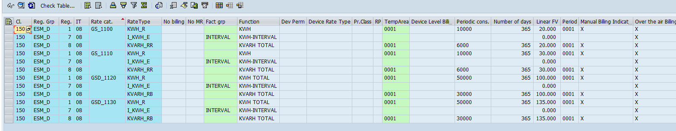

1.2 Interval Energy Profile

1.2.1 Organizational Units – Profile Type

Type: Profile Type

Logical Component: Energy Data Management

Object: Define Profile Types
Name: Define Profile Types

Configuration
Note: In this section we establish settings for profile types.
It contains the following activities:
- Define Profile Types
- Define Permissibility of Interval Length per Profile Type

SAP Path
SAP IMG SAP Utilities Energy Data Management Basic Settings Profile Type Define Profile Types

Type | Prof. Type | Category | History | Number Range
61 | Interval Profile - Ext to SAP | 1 | Historical profile | 11

Configuration Print Screen :
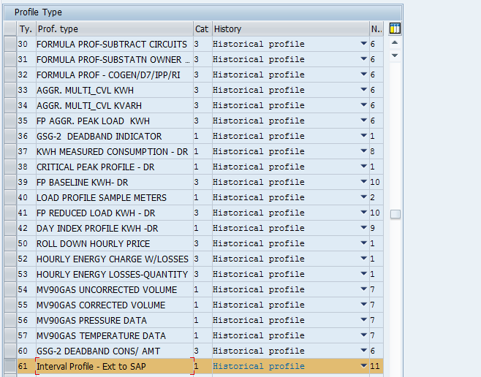

Define Permissibility of Interval Length per Profile Type

SAP IMG SAP Utilities Energy Data Management Basic Settings Profile Type Define Permissibility of Interval Length per Profile Type

Profile Type | Interval
61 | 15

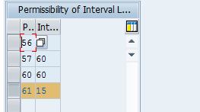

1.2.2 Organizational Units – Profile Allocation Role

Type: Allocation Role

Logical Component: Energy Data Management

Object: Profile Management
Name: Define Roles for Profile Allocation

Configuration

In this IMG activity, we define roles for profile allocation and allocate them to a role category predefined by SAP.A role describes the task of a profile during allocation to a register.In the AMI Interface, roles can be used to identify the profiles allocated to billable interval meters.Roles are used during interval billing to allow for flexible allocation of profiles to input parameters from the AMI interface.

SAP Path
SAP IMG SAP Utilities Energy Data Management Profile Management Profile Allocation Define Roles for Profile Allocation

Role | Role Description | Frequency | Role Category | Location of PV
E001 | E001 - CONSUMPTION MEASURED (KWH) ext to SAP | 1 | Measurement | Profile Value Originates from External System

Configuration Print Screen :

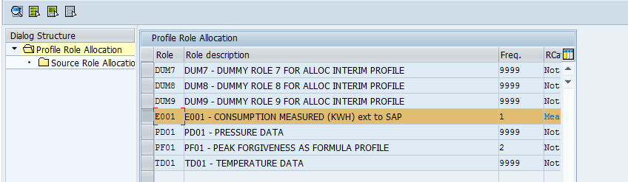

1.3 AMI -Time-of-Use Billing Configuration

1.3.1 Organizational Units – Formula Group

Type: Formula Group

Logical Component: AMI - Time-of-Use Interface

Object: Define Formula Groups for Time-of-Use Formulas

Name: Define Formula Groups for Time-of-Use Formulas

Configuration
In this Configuration activity we define formula groups, which we use to logically group together time-of-use formulas. You allocate each time-of-use formula to exactly one formula group.

SAP Path
SAP IMG SAP Utilities Energy Data Management AMI: Time-of-Use Interface Define Formula Groups for Time-of-Use Formulas

Formula Group | Text Formula group
ZEMAXDMD | Max Demand

Configuration Print Screen :

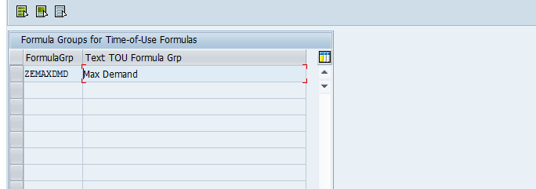

1.3.2 Organizational Units – Time-of-Use Formula

Type: Time-of-Use Formula

Logical Component: AMI - Time-of-Use Interface

Object: Edit Time-of-Use Formula

Name: Edit Time-of-Use Formula

Configuration

In this Configuration activity, you define the time-of-use formulas for billing profile values with a time-of-use interface

SAP Path
SAP IMG SAP Utilities Energy Data Management AMI: Time-of-Use Interface Edit Time-of-Use Formula

TOU Formula | Txt TOU Formula | TOU Formula Group | Formula ID in MDUS
ZEMAXDMD | Max Demand | Max Demand | 01001

Configuration Print Screen :

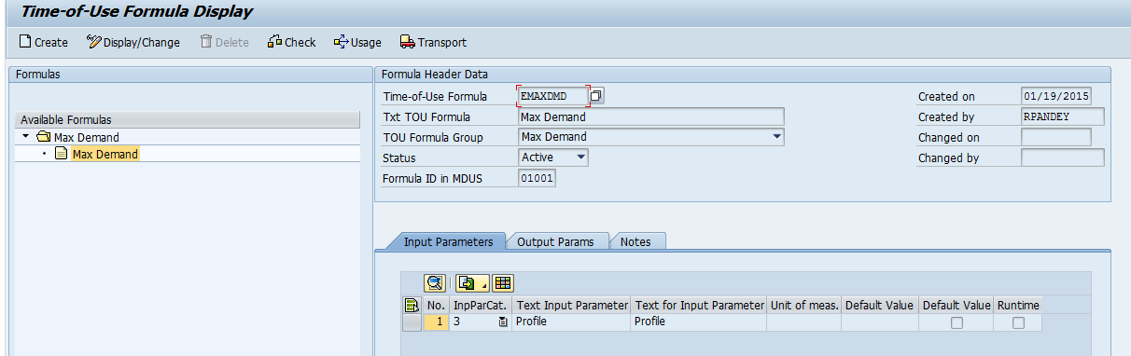

1.3.3 Organizational Units – Time-of-Use Interface

Type: Time-of-Use Interface

Logical Component: AMI - Time-of-Use Interface

Object: Edit Time-of-Use Interface

Name: Edit Time-of-Use Interface

Configuration

In this Configuration activity we define time-of-use interfaces. Time-of-use interfaces are allocated rates, which are permitted for interval meters and allow the billing of profiles.

SAP Path
SAP IMG SAP Utilities Energy Data Management AMI: Time-of-Use Interface Edit Time-of-Use Interface

TOU Interface | Txt TOU Interface | Result Parameter | Execution
EMAXDMD | EMAXDMD - Max Demand | MX_DMD | Billing of profile values in External System

Configuration Print Screen :

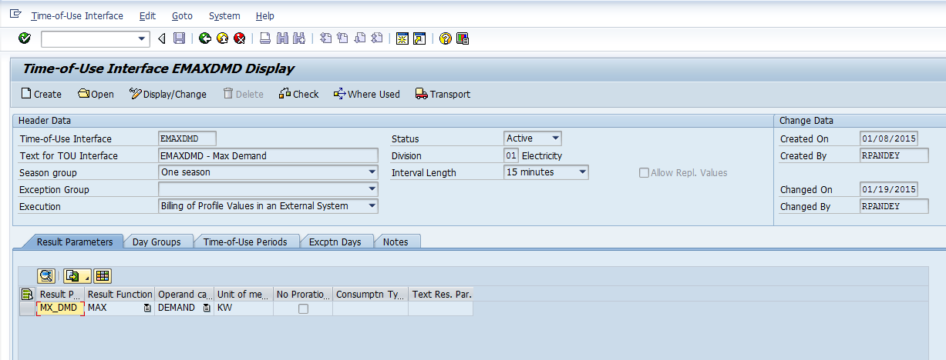

1.4 Billing – Billing Master Data Configuration

1.4.1 Organizational Units – Rate Type

Type: Rate Type

Logical Component: Billing Master Data

Object: Billing Master Data

Name: Rate Type

Configuration
In this IMG activity we define required rate types. The rate type classifies the register for billing.
SAP Path

Utilities Industry -> Billing -> Master Data -> Define Rate Types

New Register Rate Types | Set on AMI Meter Register | Permissibility
I_KWH_E | AMI Interval Meter - KWH | Permitted for interval meters

Configuration Print Screen

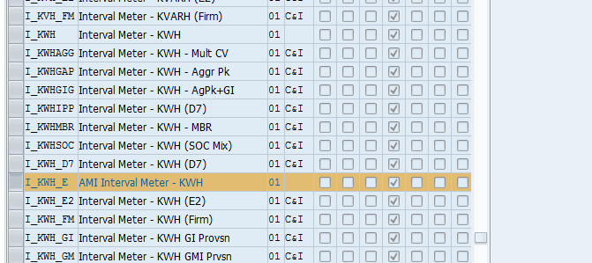

1.4.2 Organizational Units – Operand

Type: Operand

Logical Component: Billing Master Data

Object: Billing Master Data

Name: Operand

Configuration
In this IMG activity we define operands. Operands are required for structuring rates. Operands form the link between the values to be billed and the variant programs.

SAP Path

Utilities Industry -> Billing -> Master Data -> Define Operands

New Operands | Comments
D1C_KW_MXE | This is RTP operand with operand category DEMAND
DEM1C_KWTE | This is normal usage operand with operand category DEMAND (Constant)
KW_MX_DEMR | This is normal usage operand with operand category DEMAND (run time).
D1C_KW_MX | This is normal usage operand with operand category DEMAND (run time).

Configuration Print Screen

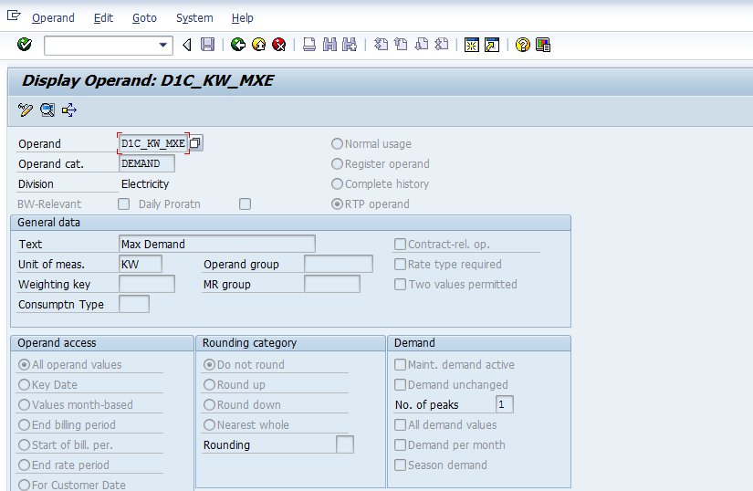

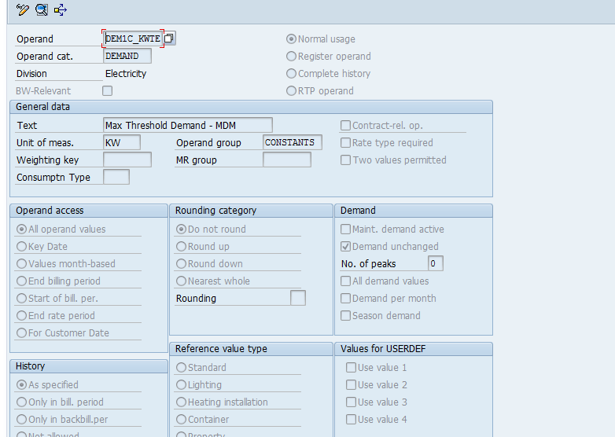

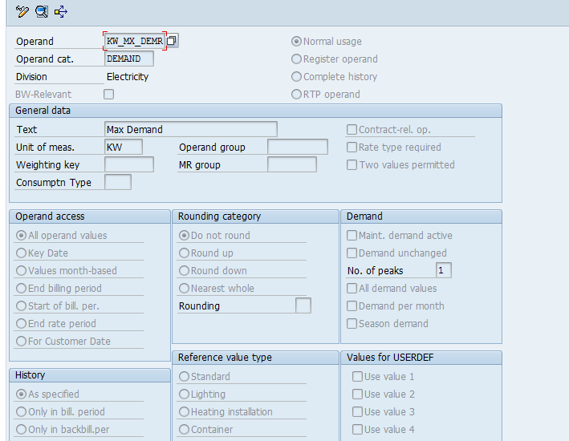

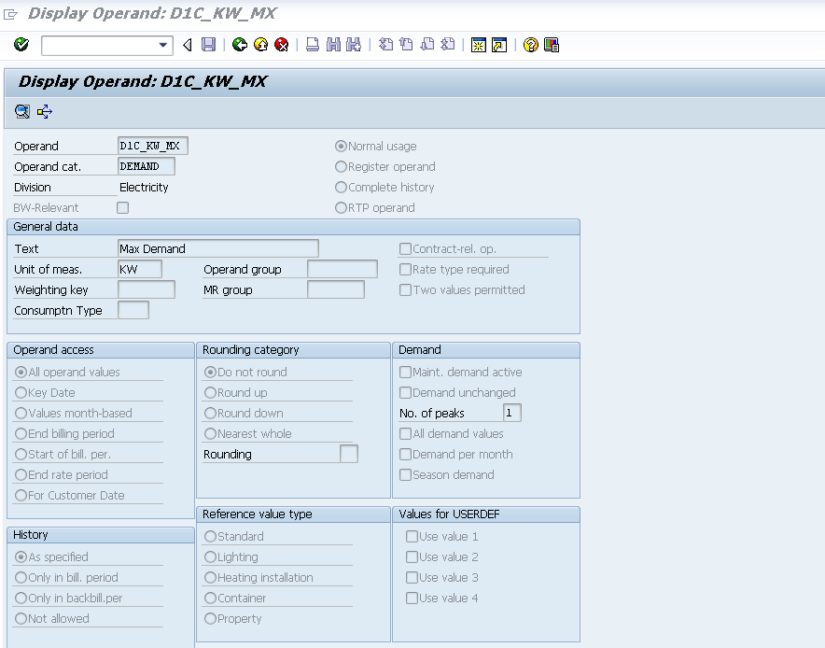

1.4.3 Organizational Units – Rate

Type: Rate

Logical Component: Billing Master Data

Object: Billing Master Data

Name: Rate

Configuration

In this IMG activity we define rates. A rate consists of a key, header data and one or more rate steps with variant programs.The variant program represents the central part of the rate. It depicts the billing rules for post cutover to interval billing – max demand.

SAP Path

Utilities Industry -> Billing -> Master Data -> Define Rate

New  Rates | Text | Permissibility | RTP Category
ES_MXKW_IE | TOU - Max Demand (KW) | Interval Meter | 02 - Bill External Profile Values with TOU Interface
ES_MXKWR_I | TOU-Max Demand Read Only | Interval Meter | 02 - Bill External Profile Values with TOU Interface
ES_KW_I_E | Compare Demand : Choose Max Dema for AMI Interval | Facts | None

Configuration Print Screen

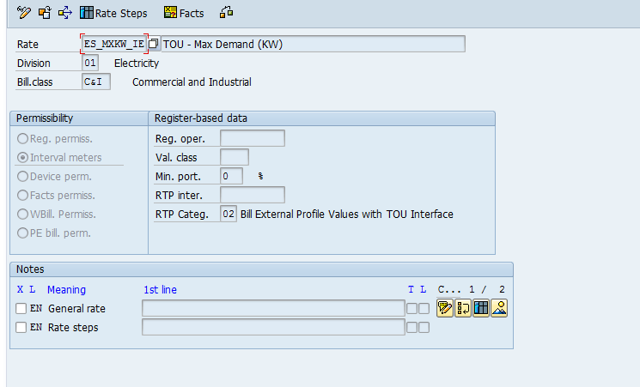

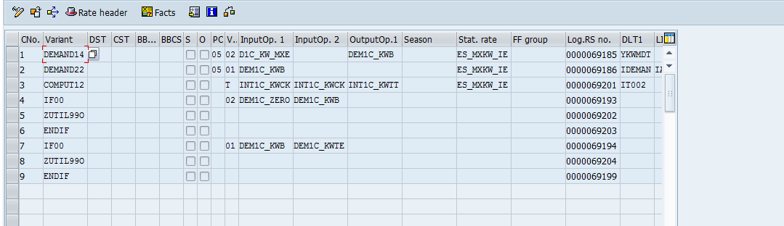

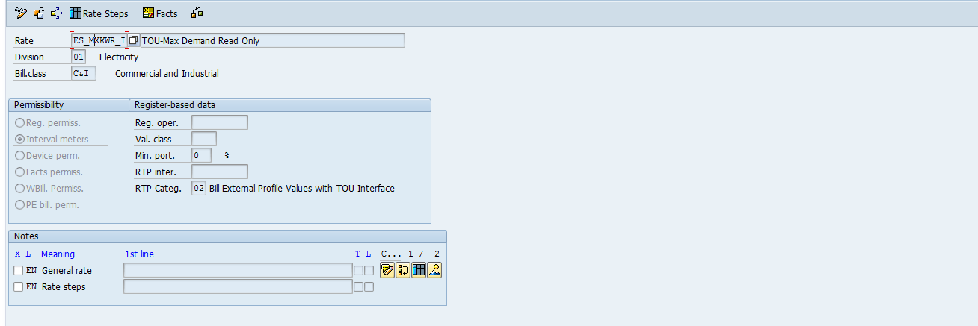

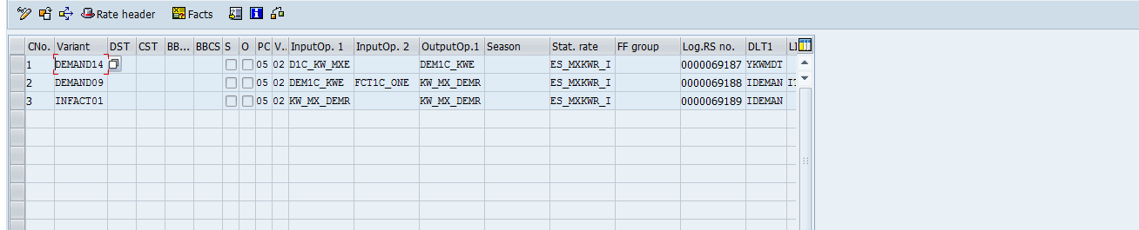

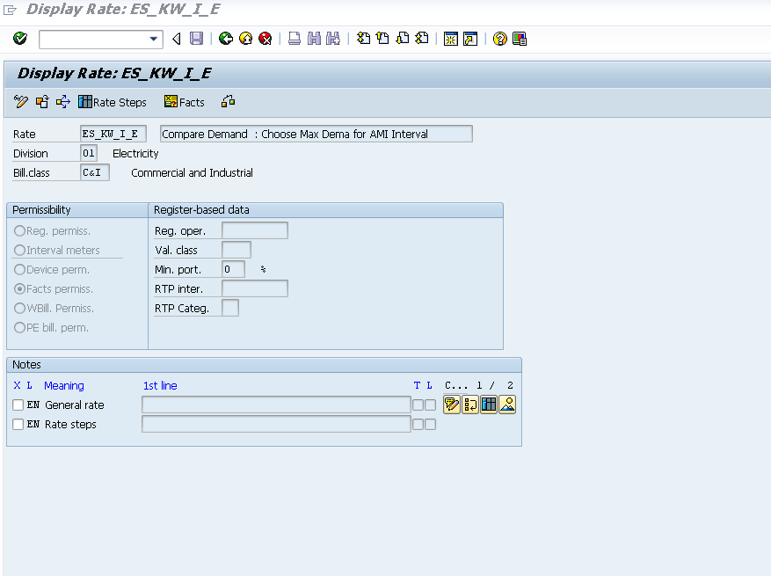

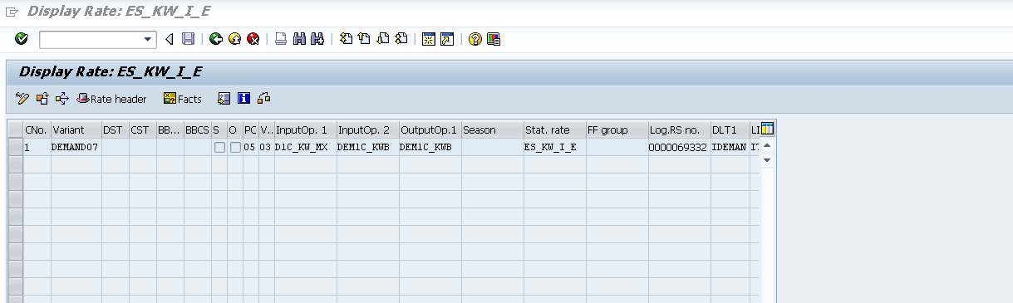

1.4.4 Organizational Units – Schema

Type: Schema

Logical Component: Billing Master Data

Object: Billing Master Data

Name: Schema

Configuration

In this IMG activity we define required schemas. In the schema, we establish which rates are billed and in which sequence the rates and variant programs are to be executed.

Schema SAP Path
Utilities Industry -> Billing -> Master Data -> Define Schemas

Existing Schema | Text
SEC_ELEC | Secondary Electric Schema (Rate Case)

Configuration Print Screen

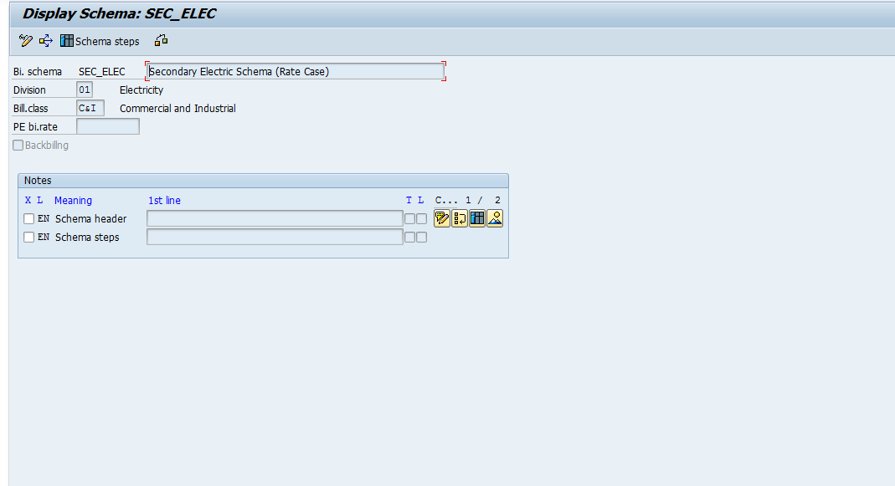

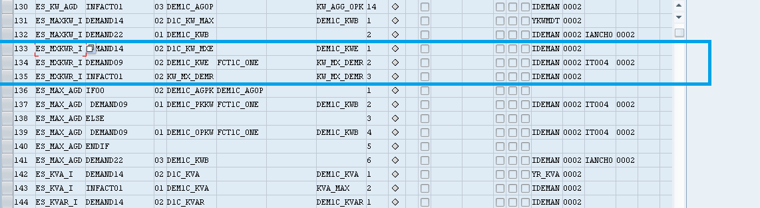

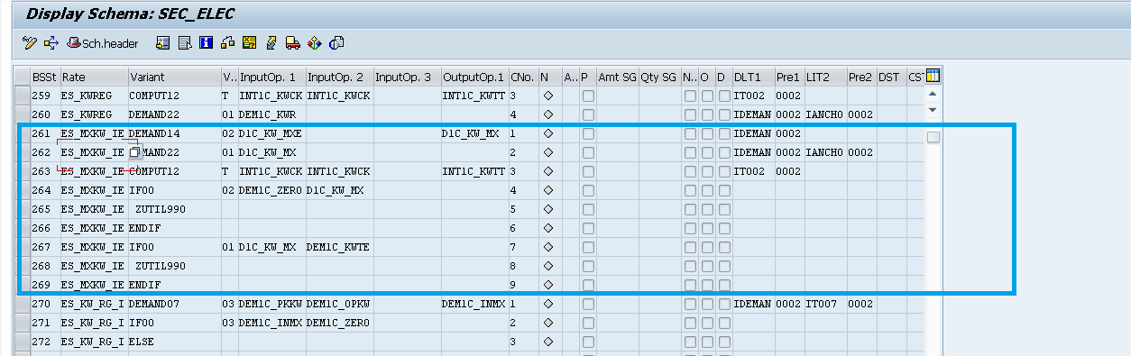

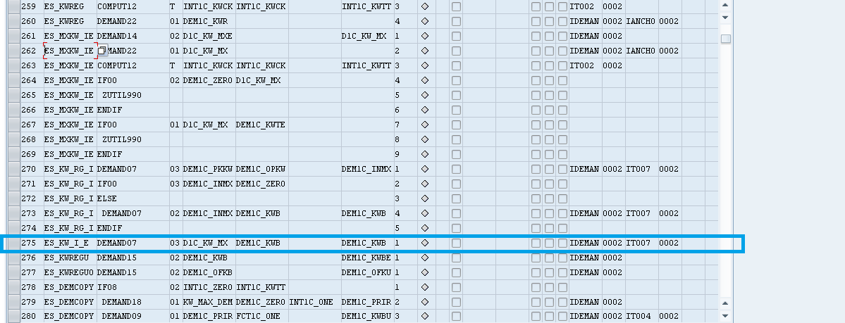

1.4.5 Organizational Units – Rate Category

Type: Rate Category

Logical Component: Billing Master Data

Object: Billing Master Data

Name: Rate Category

Configuration

In this IMG activity , Only rate category facts updated to support newly created rates for Interval billing .

SAP Path
Utilities Industry -> Billing -> Master Data -> Define Rate Categories

Existing Rate Categories | Billing Class
GSD_1120 | C&I
GSD_1130 | C&I
GS_1100 | C&I
GS_1110 | C&I

1.4.6 Organizational Units – Rate Determination

Type: Rate Determination

Logical Component: Billing Master Data

Object: Billing Master Data

Name: Rate Determination

Configuration

In this IMG activity we define rate determination. We do not enter the rate in the master data. Rather, the rate is determined dynamically (at runtime) from the rate type of the register and the rate category of the installation.

SAP Path
Utilities Industry -> Billing -> Master Data -> Define Rate Determination

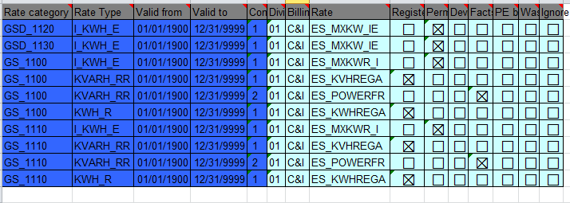
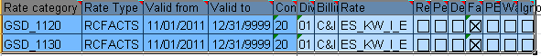

1.5 Enhanced Message Management

1.5.1 Organizational Units – EMMA Case Category

Type: EMMA Case Category

Logical Component: Exception Management

Object: Maintain Clarification Case Categories
Name: Case Category

Configuration

SAP Path
SAP IMG SAP Utilities Exception Management Specifications for Generating Cases Maintain Case Categories
Case Category | Text | Message Class | Message No | Processor Rule | Processes
EB65 | OTA Demand was Estimated | ZBILL | 224 | 93100080 | Display Meter Reading Result , Premise Environment,Forms Menu Interface
EB66 | OTA Demand Missing or Invalid | ZBILL | 225 | 93100080 | Display Meter Reading Result , Premise Environment,Forms Menu Interface
EB67 | Interval Value has changed | ZBILL | 226 | 93100080 | Display Meter Reading Result , Premise Environment,Forms Menu Interface

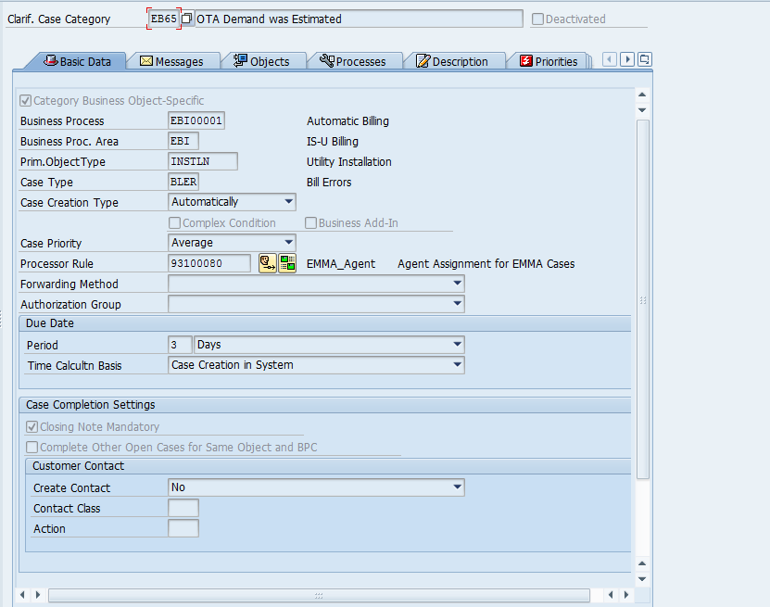

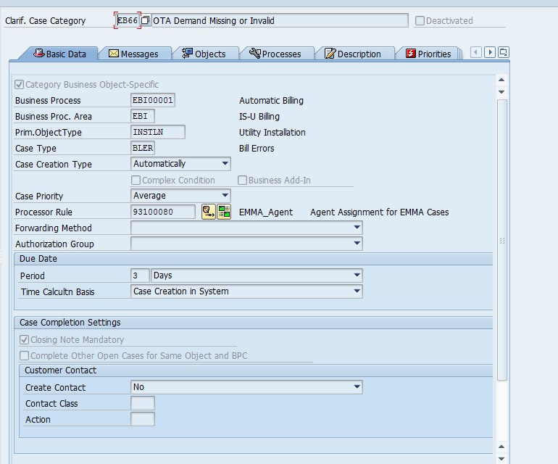

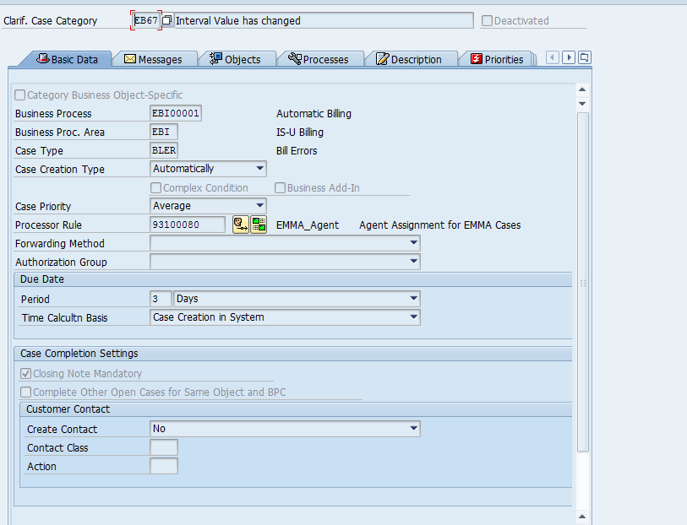

Solution Manager Sub-Process Path: | N/A
Document Name: | PJT03023.Power.Factor.Configuration.Document.Billingv0.2.docx
Created By: | Rajesh Pandey |  | Date Created: | 02/02/2015
Change History:
Support Ticket Number (post go-live) | Transport Number | Changed By: | Description of Change: | Change Date:

2 Contributors

Name | Organization | Area of Contribution
Rajesh Pandey | Capgemini | SAP Billing
Pete Hirth | CMS | SAP Billing
Srikanth A. Buddarraju | CMS | SAP Device Management
Dominic Pappaly | Capgemini | EMMA
Mary Jane Afable | SAP | EMMA

